**Aim:** To create S3 bucket using Terraform.

**Steps With Screenshots:**

* Download **“atom”** from <https://atom.io/> .

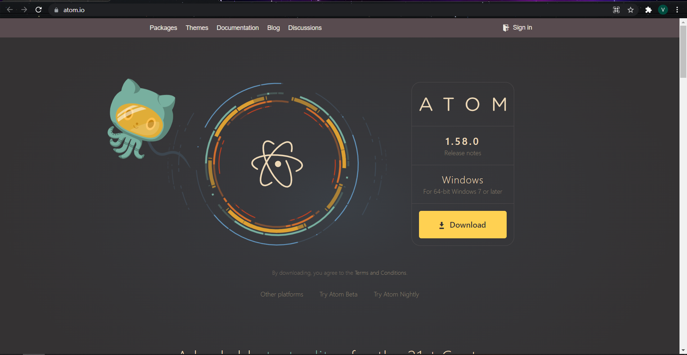

* Now login to your AWS Account and select **“My Security Credentials”.**

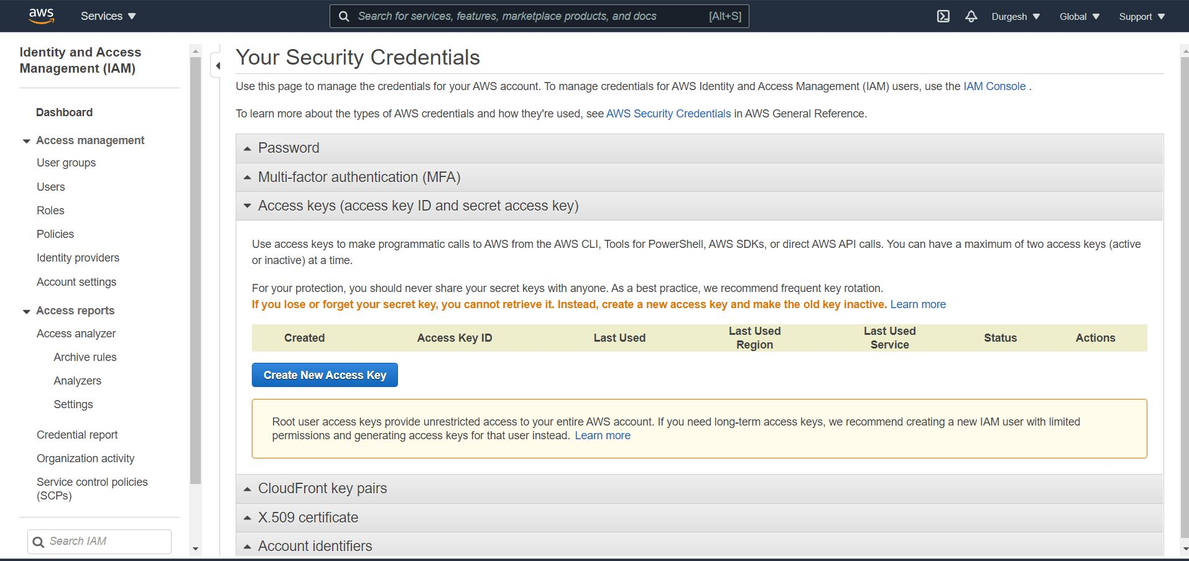

* Under **“Access Keys”** option click on **“Create New Access Key”** button you will get your ACCESS KEY ID & SECRET KEY

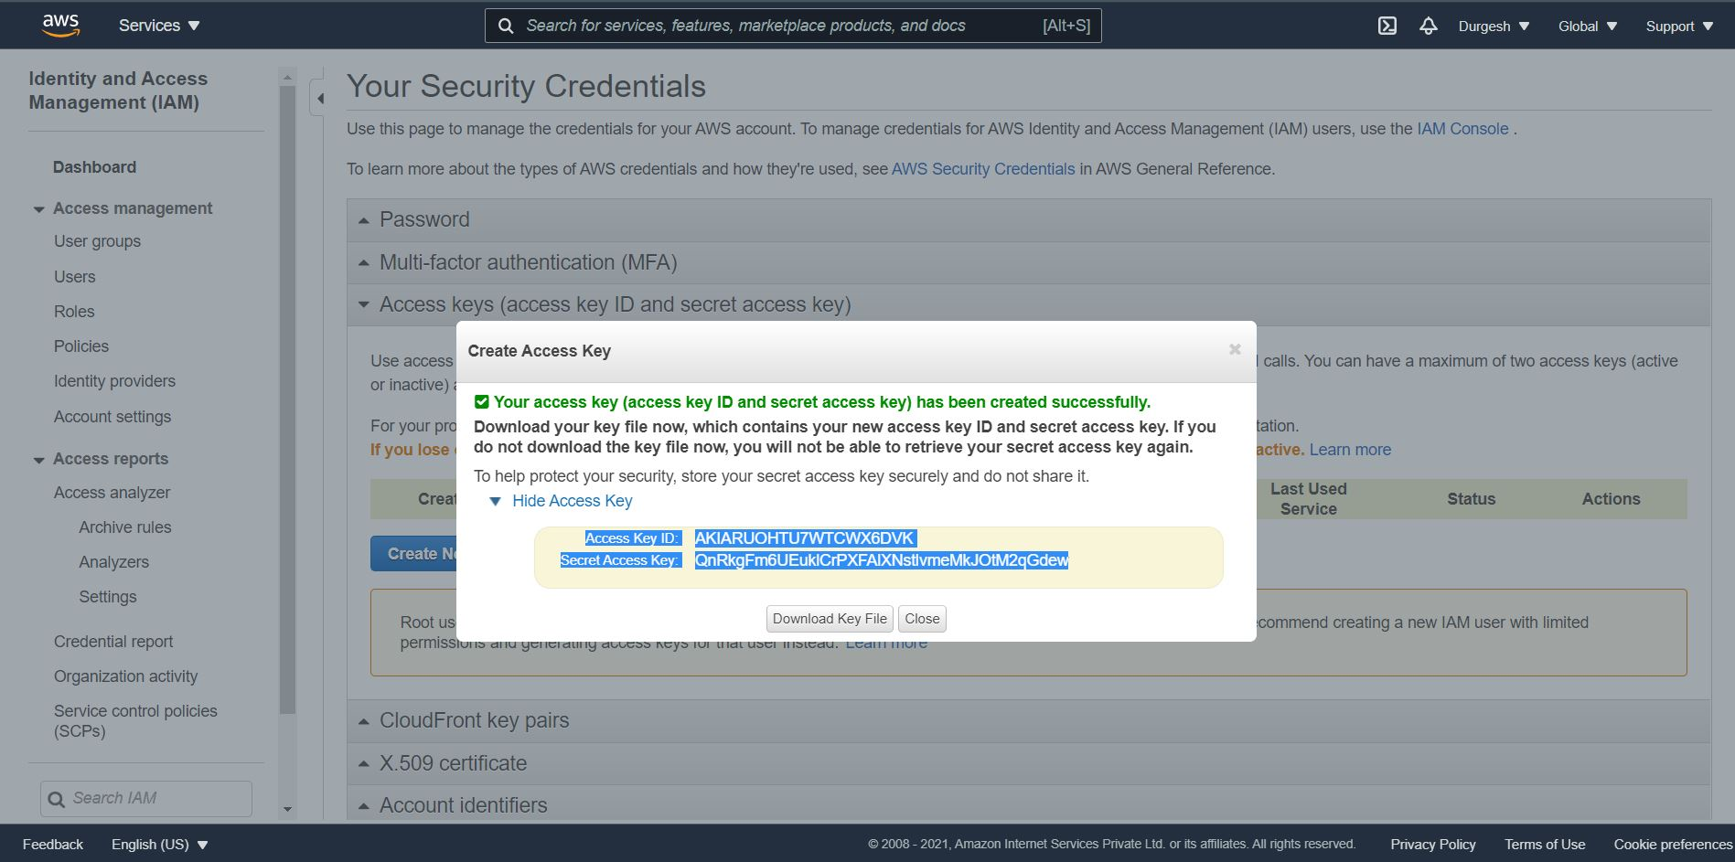

* In **“atom”** create 2 files of terraform in which 1st file will include resource, bucket name**(“vaish-terraform-bucket**”) also you can add tags and in 2nd file you have to add your **“access key”** and **“secret key”** which were generated and save them in a same folder with .tf extension.

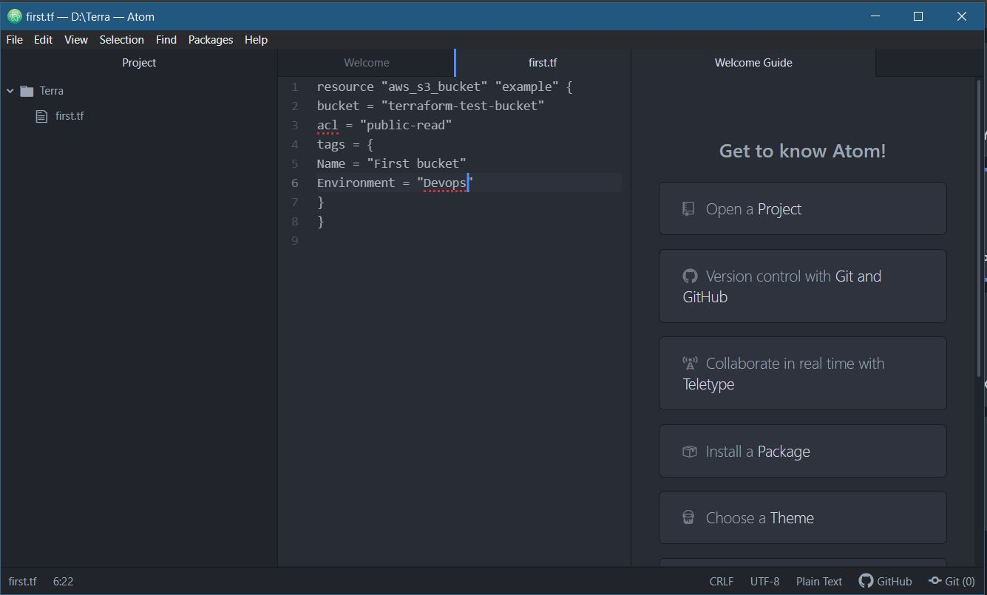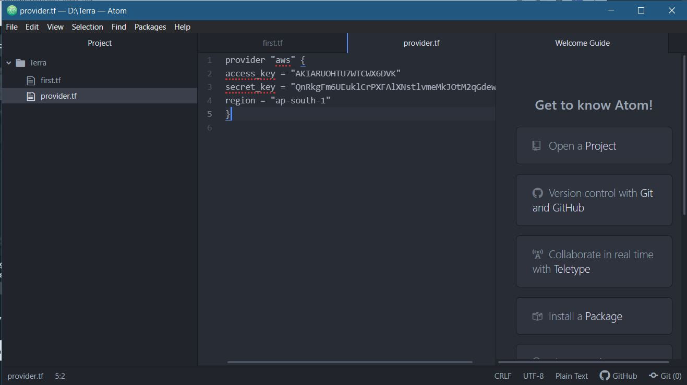

* Now run your command prompt as administrator and change the path where two terraform files are saved.

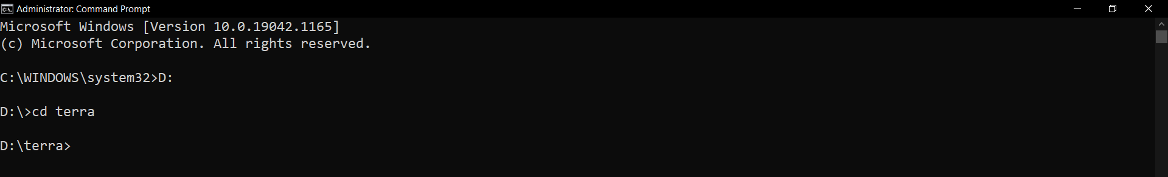

* Initialize terraform by command **“terraform init”**

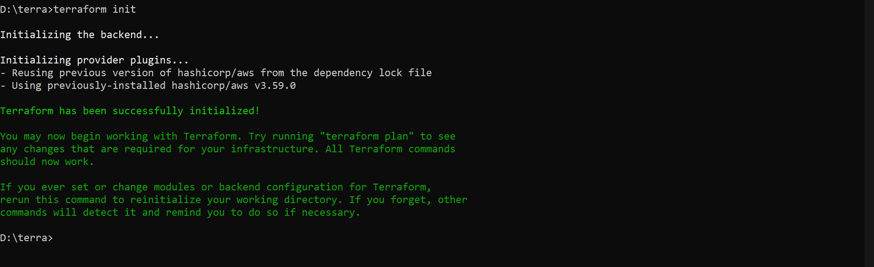

* Execution plan by command **“terraform plan”**

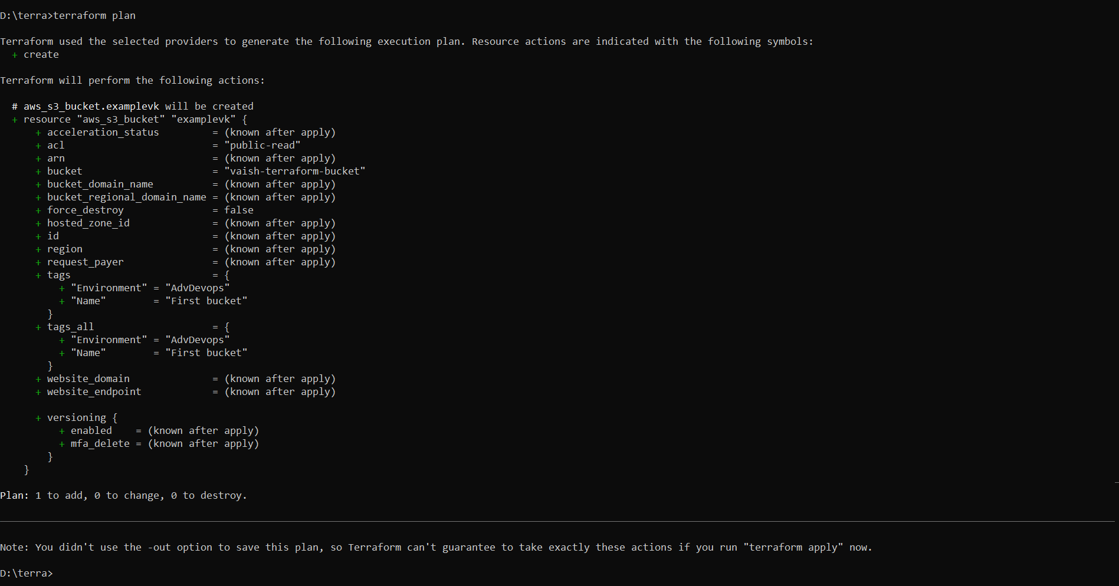

* Before **“terraform apply”** command you can see that there is no bucket in my AWS S3 Console.

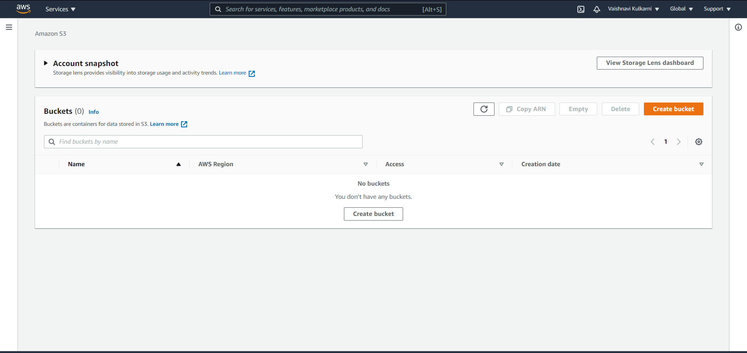

* Actions proposed in a Terraform plan by command **“terraform apply”** by this command your S3 Bucket will be created in you AWS Account.

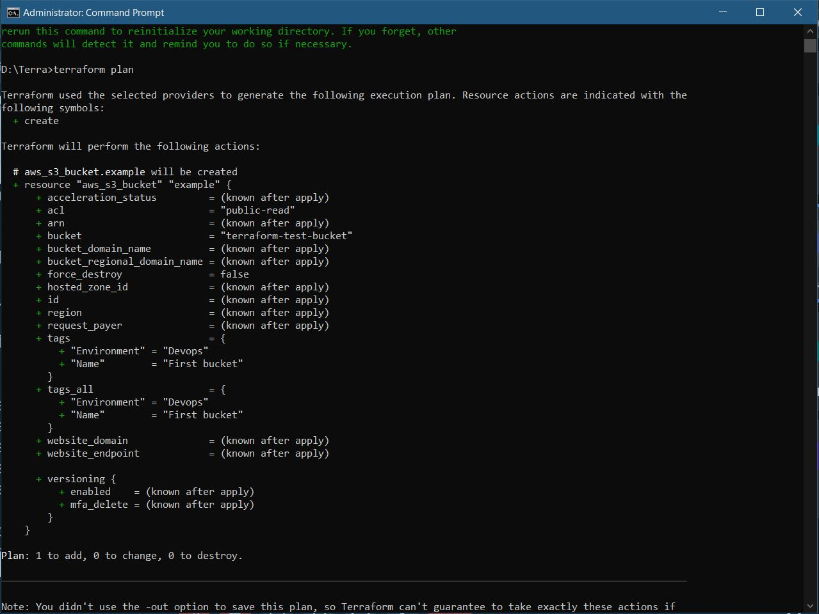

* After applying **“terraform apply”** command bucket is created in my AWS S3 Console.
* We can also delete/destroy this bucket using terraform command

**“terraform destroy”.**

* Now again in AWS SE Management console you can see the bucket got deleted.

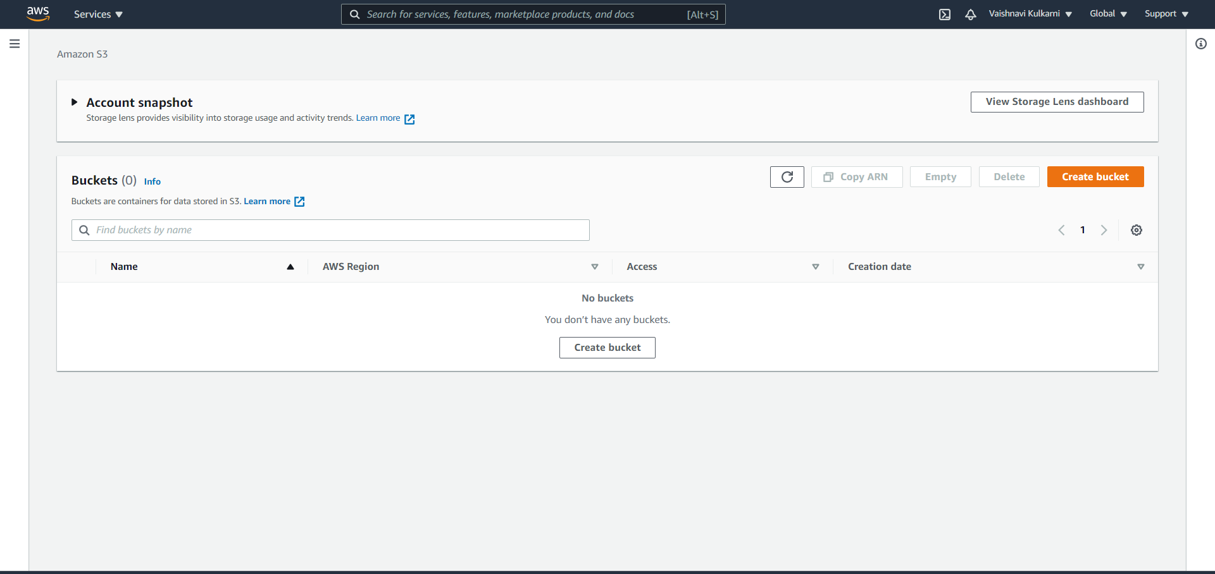

**Conclusion:**

In this expt we learned how to create S3 Bucket by using TERRAFORM with the help of various terraform command to execute and also, we used “atom” for creating terraform file.

**Lab Outcome:** ITL504.3

To apply best practices for managing infrastructure as code environments and use terraform to define and deploy cloud infrastructure.